PurplePay: TIMS3311

Joaquin Garces
Student ID: 48820563
Word Count (Essay): 1518
Word Count (Diaries): 793
Contents
What PurplePay taught me about people, timing and myself 2
Diary entries: 5
August 15th and September 4th: Website development & Jack A1 Feedback 5
September 6th: App development 5
September 30th: Jack App feedback 5
Week of October 6th: First Interviews 5
Week of October 13th: Weekend Interviews 6
References 6
Appendix 6
Appendix 1 (Leadership Graph) 6
Appendix 2 (Website) 7
Appendix 3 (App V1) 7
Appendix 4 (App V2) 8

What PurplePay taught me about people, timing and myself
I was presented with three options, join a iLab/UQ startup, do a corporate placement, or build my own venture. I have studied entrepreneurship for almost a year, but I had never actually tried to build a startup. There was a big problem I had no idea or plan for it.
I started this WIL doing the think Jack told us not to do, “interview first and then do MVP”. From the beginning Jack warned us to interview first and build later, following the basics of the entrepreneurial theory. For the own venture he suggested a mix of 40% Effectuation, 40% Lean Startup, 20% Design Thinking. In short, effectuation focuses on taking smart action with the resources you already have, rather than writing detailed business plans (Effectuation.org, 2024). “Start with what you have, build as you go.” Use existing resources, find early partners and customers, focus on affordable losses, and adapt goals based on feedback. From this course, effectuation became my main rule. I tried to use everything I knew about business. My approach was affordable loss, how much was I willing to risk to build this? I wanted something cheap to build with high scalability, a SaaS (Software as a Service). I chose to build a SaaS without hiring developers by using AI.
Together with that, I applied Lean Startup thinking and the idea of minimum viable product (MVP). I could not afford months or years building the “perfect” product. I needed something to test the market. Build, measure, learn. The core activity of a startup is to turn ideas into products, measure how customers respond, and then learn whether to pivot or persevere (Ries, 2011). So, I planned to build an MVP, pitch it, get feedback and improve. That was my approach, learn as much as I could from potential customers. But who were my customers? I’m a student, my best resource is access to thousands of students at the uni. Finally, Design Thinking. I aimed to understand the problem before building a solution. Interviewing students seemed like the best path. Ask them and get answers, easy. But I had no firm idea or plan. So what problem was I trying to solve? I started with what I care about, finances. Everyone needs to understand personal finances, but not everyone does. According to the theory, I should empathise, define, ideate, prototype, and test (Dam, 2025). I should have followed this plan to apply Design Thinking well. But I didn’t.
I started by building a website, PurplePay Finances. It would solve many student finance problems, budgeting and money management, banking and savings, investing basics, HECS debt, scholarships and grants, living expenses, and cost of living. The list was long. In my head, this was it, I was solving everyone’s problems. What qualified me? Technically, nothing beyond self-learning and a couple of university courses. I am an accountant, and I thought that gave my service some credibility. I was waiting for the pitch night, 25th of August. This would be the first feedback I would get after building my MVP. All I needed was a bit of encouragement to keep going. The pitch was so complex, that if at the time you would ask me what I was doing, I could give 20 different answers and still be unclear to tell. Jack’s advice was, focus on one issue. So I did, I went to the basics, budgeting. I was going to solve budgeting for students so they could save more money, not stay paycheck to paycheck. But how? Am I going to give free advice? Excel templates? Youtube channel? So many ideas but not very concrete until I remembered Ad I saw on Youtube. AI App builder. It instantly clicked, I was going to do a budgeting app for students. Where I could offer them budgeting so they could track their finances and a section to learn, like Duolingo. This way I would be solving their budgeting issues and teaching them about finances.
So I spent the next 3 days approximately building the app, and there I had it. I built my second MVP, this time, it was more focused on what I was going to do, and it was free at this point. So I showed to my friends, family, and people I knew from class. Everyone was telling me this was a great idea and I was amazed. This would solve students their budgeting issues. But I needed feedback from a less unbiased opinion, on the 30th of September I had a meeting about PurplePay with Jack, he said that was very good, but it was still too broad. Am I offering a budgeting app or a teaching app? Both was still trying to solve more than one issue. What was I doing with the customer feedback? I didn’t had any, everyone that I’ve asked was known people to me, my network. Jack insisted to reach out and interview students so they would give me real and pure feedback. So that was my next goal.
Not before rebuilding the MVP. I redesigned the app from scratch, a cleaner dashboard with small widgets for spending, saving rate, pie charts, projected balance, and bill reminders. I added a calendar, budgeting, and transactions tab, each showing what you earn and where the money goes. Then I felt ready to interview. I started with classmates I barely knew. Those interviews were more than 30 minutes, great answers, lots of detail, the kind of feedback I wanted. Next, I went to speak with students I didn’t know. That’s when disappointment hit. Walking the campus was mentally exhausting. Each time at uni, I asked about 20 people for a 30 minute interview on personal finances and 18 out of 20 said no. The first lesson was timing. I was arriving after work, around 4:30 pm, and staying until 7:00 pm just as most students were leaving. The default reply was “no thanks.” After the first week (two after work sessions and one after class), I changed tactics. I tried weekends so I could approach people in the morning, hoping they’d be fresher. I hit a second wall. Almost nobody on campus Saturday or Sunday was there to nots study, they were studying with headphones on. I felt awkward interrupting them, and they looked busy.

The good interviews were not giving me much though, looking at people say that they would probably not use the app was insanely hard, but I was hoping for that moment, so I could ask the why. I was genuinely trying to understand why not? Here the top answers: “Why would I pay to save money?”, “I just check the bank.”, “I live with my parents, so I don’t have major expenses.”, “I have my basic excel that helps me at least understand what I need for the month” My pivot moment was this one though, instead of charging students, I would make it free for students and try to monetize it in another way, so the money wouldn’t be an excuse. This for me was easy, because the app itself didn’t cost me much aside from my time. Partnering with Universities to make it free for students and charge “adults”. But still, after more interviews, I started realising something, it was a solution to a problem that didn’t exist, and effectuation theory would have told me that way sooner, if I had interviewed about the issue before building the app, I would have had a better idea and understanding of what I would need to build to solve a problem, a clear pain point for students.
First, for TIMS3310, another of my classes, I did a leadership test, the result? High on ambition, high on control, high on perfection (Appendix 1). Looking back at these last 6 weeks, it is obvious, that I like perfection, even if it didn’t take me months or years, I tried to build the perfect product to the find the solution. I applied almost nothing of design thinking theory here, I did improve the efficiency though, thanks to the resources at hand I was able to build what it would take a team of developers for months in a couple days.
Secondly, after asking 80+ people around university, I would text my girlfriend after every no ranting about how hard it was to get a very long interview with a stranger, but that didn’t stop me from going for another no. This was my persevere moment, it was either do or do. Lastly, after every interview I would try to learn and re design something in my app, that was great insight. This was the closet to try to apply the lean startup theory, where after every feedback I would try to improve, this was my pivot part. The application of the theory is very complex and very different that textbook ideas, I learn that Instagram and TikTok are full of lies. It is not as easy to ask 200 people everyday to get one sale. Not that I did that, but what I’ve learn is that it is hard reaching out cold.

Diary entries:

August 15th and September 4th: Website development & Jack A1 Feedback
I have chosen the own venture path because it is the first time I was given the choice to do a real life experiment with business, I have always dream of owning my own business, but never had a clear idea. So started by a topic that I really care about, finances. And I did a survey in the class which gave me around 30 answers and 80% positive feedback and I built a website called PurplePay Finances (Appendix 2). I tried to solve many student issues at once, budgeting, banking, saving, investing, debt, cost of living. In my head, this was perfect. It was too much, I couldn’t explain it in one clear sentence. Jack’s advice for A1 is to focus on one thing. So, I started focusing only on budgeting and learning so if someone asked “what is PurplePay” I no longer had 20 answers and have one straightforward answer. Being broad made it vague.

September 6th: App development
After the feedback I have decided to move from website to app. I used an AI app builder so I could make something fast and cheap. This was my affordable loss one month of a tool and my time. I built a first MVP in about three days. The app had a simple dashboard and tabs for calendar, budget, and transactions and a learning section where I would teach students basic finances, like Duolingo. It showed spending, saving rate, and upcoming bills. I shared it with friends, family, and classmates I know. The feedback was very positive. People said it was a great idea, but I knew it was biased because they know me. My lesson was building is the part I enjoy most, but positive comments from my network are not real validation. I needed to hear from students who did not know me.

September 30th: Jack App feedback
I had a meeting with Jack via zoom about the app. He liked the effort but said it was still too broad. Was I a budgeting tool or a teaching tool? Doing both was still trying to solve more than one issue. He asked what I was doing with customer feedback. I have not had more than a couple interviews with my friends so no real interviews yet. So I had built first and interviewed later. Jack told me to go and interview students I did not know and get honest, clean feedback. I left the meeting with a new plan, stop building the app and start talking to students.

Week of October 6th: First Interviews
I redesigned the MVP to make it cleaner, small widgets, a clear dashboard, budget, calendar, and transactions and got rid of the learning part, so I’m focusing only on the budgeting part. Then I went to UQ after work. From 4:30 pm to 7:00 pm I walked the campus and asked for 30 minute interviews about personal finance. Most people said no. On each visit I asked between 15 and 20 students, and around 18 said no. The first lesson was timing. At that hour many students were leaving. I felt drained and a bit embarrassed, but I kept going. I tried starting with classmates I barely knew. Those longer talks went well, but they were still close to my network. From the few short talks with strangers I learned two things, the 30 minute ask was too big, and “budgeting” sounded like homework. Some students said, “I just check the bank,” or “I live with my parents.” So I pivoted to shorten the ask to 10 minutes and ask concrete questions like “What bill surprised you this month?” instead of big life questions leaving aside Jack’s criteria of 30 minute interviews.

Week of October 13th: Weekend Interviews
I changed tactics and tried mornings on the weekend. The campus was quiet. Most people there were studying with headphones on. It feels very awkward to bother them. I still asked, but again I got many “no thanks.” It was mentally hard to keep asking after so many rejections. I texted my girlfriend after each no to complain lol, then I went for one more try. From the few who did talk, I heard some similar things such as “Why would I pay to save money?” “I just check my bank.” “I use a simple Excel.” This pushed a pivot in my head, if I ever charge, students will say no. Make it free for students and find another way to fund it later. Even with that idea, I also saw a bigger truth, maybe many students do not feel this problem strongly. This is why I need to interview first, build later. Keep the time small, the questions specific, and accept that “no” is data. I will keep my affordable loss small, use my energy better (midday, not evenings), and test the problem before I add new features.

References
Dam, R. F. (2025). The 5 Stages in the Design Thinking Process. Interaction Design Foundation; IxDF. https://www.interaction-design.org/literature/article/5-stages-in-the-design-thinking-process
Effectuation.org. (2024). What is Effectuation? Effectuation 101. Effectuation.org. https://effectuation.org/effectuation-101
Ries, E. (2011). The Lean Startup | Methodology. Theleanstartup.com. https://theleanstartup.com/principles

Appendix

Appendix 1 (Leadership Graph)
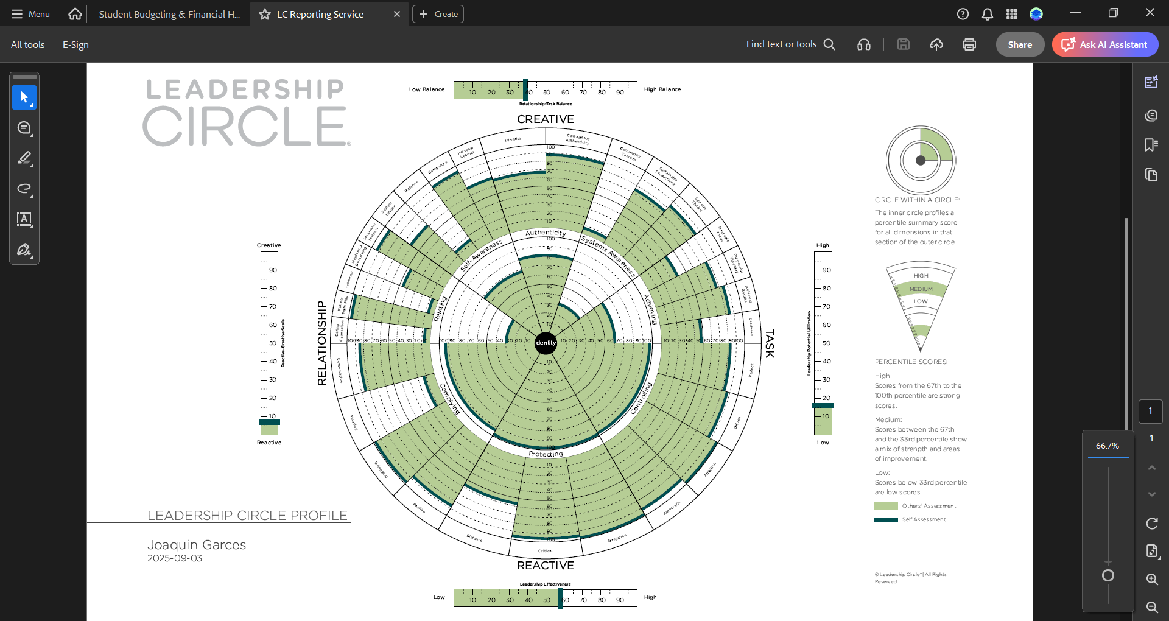

Appendix 2 (Website)
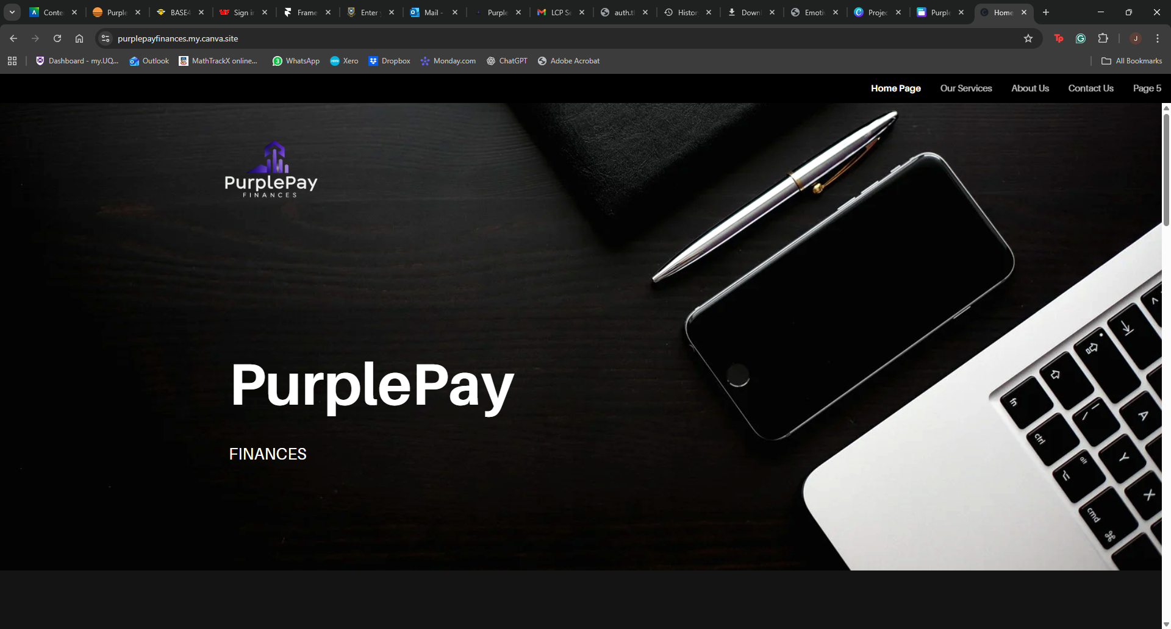

Appendix 3 (App V1)
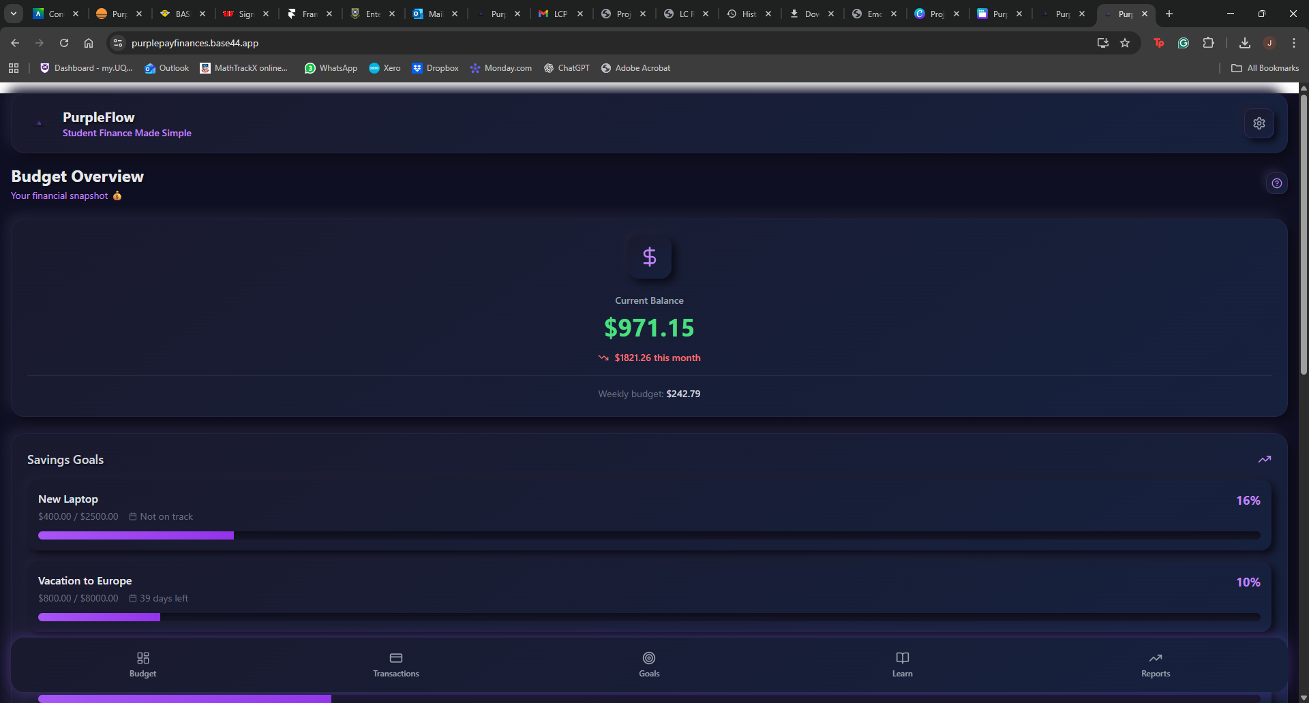

Appendix 4 (App V2)
